Case 1

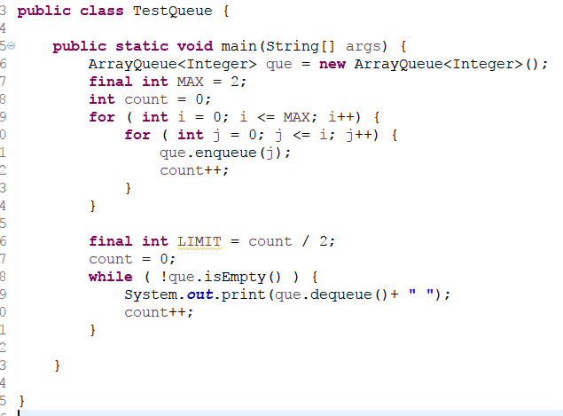

Input Variable Name: que

Output

Debug Point : 12

|  |  |  |  |  |  |  |  |  |  |
| --- | --- | --- | --- | --- | --- | --- | --- | --- | --- |
| 0 | 0 | 1 | 0 | 1 | 2 |  |  |  |  |

first rear